WF – HOMEPAGE
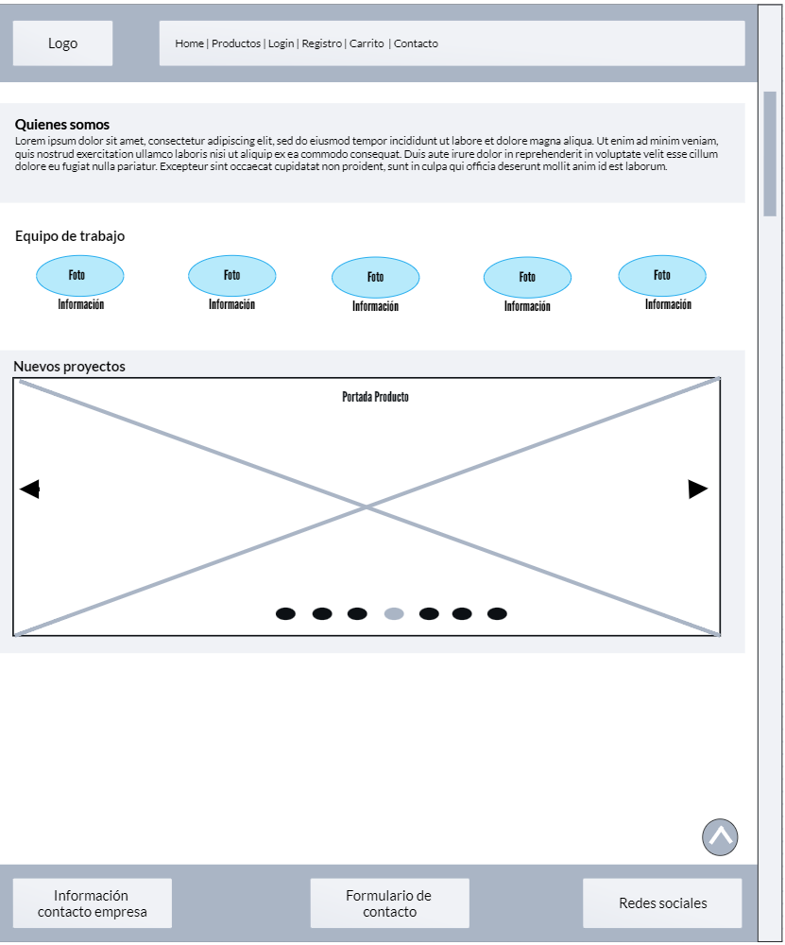

WF – LISTA DE PRODUCTOS
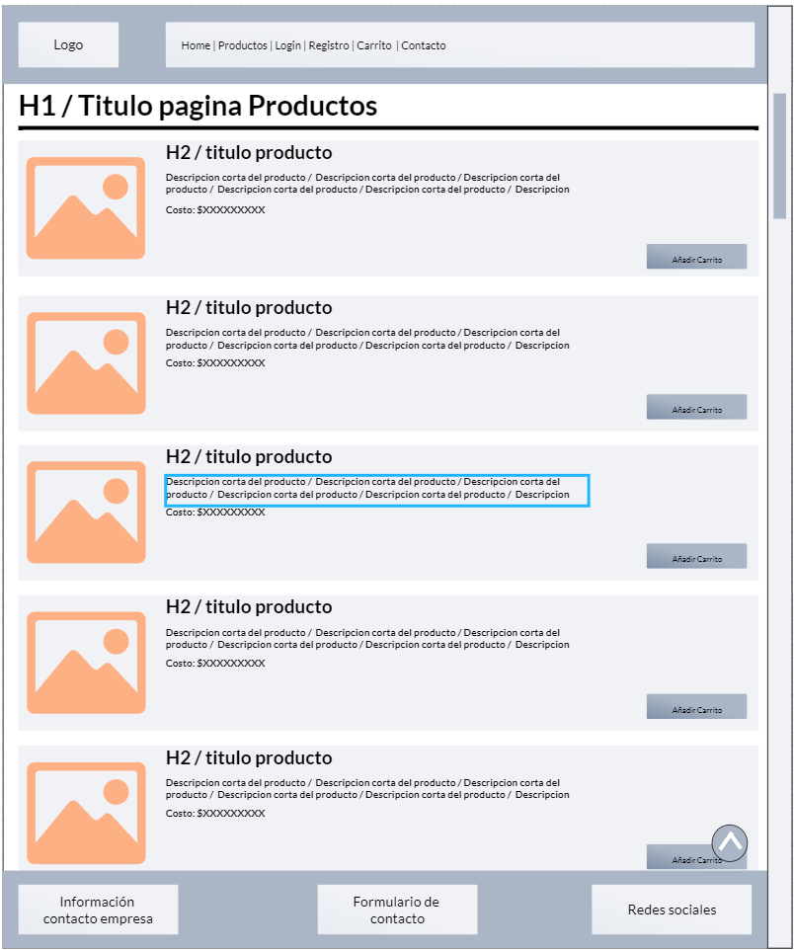

WF – CARRITO DE COMPRAS
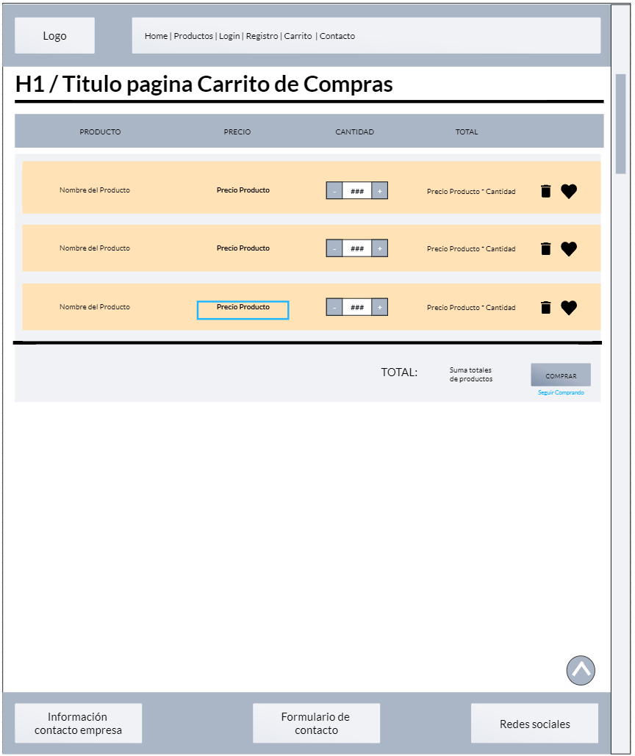

WF – REGISTRO
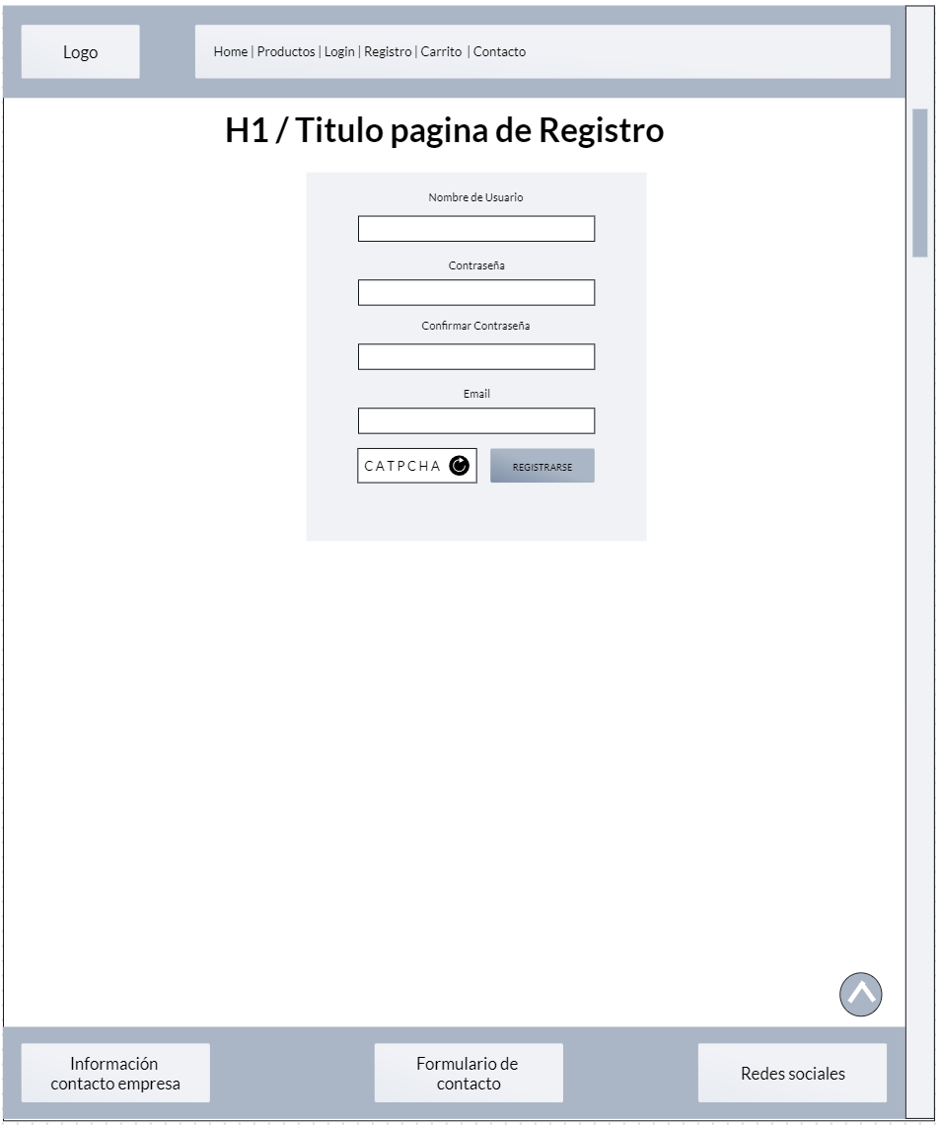

WF -LOGIN
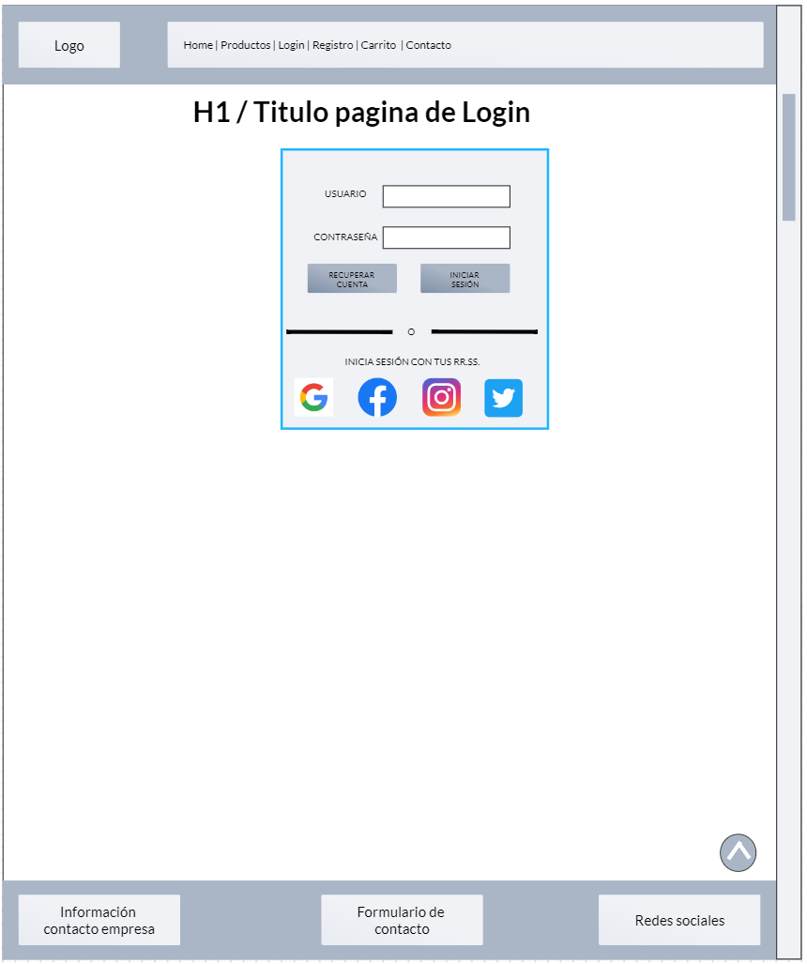

LINK WF: https://marvelapp.com/whiteboard/fJAZIDoO09HIFQ2GfiKS

